2021150456 통계학과 이예지

>> 1+3

ans =

4

>> 13-4

ans =

9

>> 12*3

ans =

36

>> 36/3

ans =

12

>> x = [1 2 3 4 5]; y = [5 4 3 2 1];
>> x < y

ans =

1×5 logical 배열

1 1 0 0 0

>> x <= y

ans =

1×5 logical 배열

1 1 1 0 0

>> x == y

ans =

1×5 logical 배열

0 0 1 0 0

>> x >= y

ans =

1×5 logical 배열

0 0 1 1 1

>> x > y

ans =

1×5 logical 배열

0 0 0 1 1

>> for x=0:2:10
a=2^x
end

a =

1

a =

4

a =

16

a =

64

a =

256

a =

1024

>> a=3;
>> if a<1
b=a+1
else
c=a+2
end

c =

5

>> a=1;
>> while a<4
a=a+1
end

a =

2

a =

3

a =

4

>> a=1; b=2, c=3;

b =

2

>> plot(x,y,'--rs','LineWidth',2,'MarkerEdgeColor','k', ...
'MarkerSize',10)
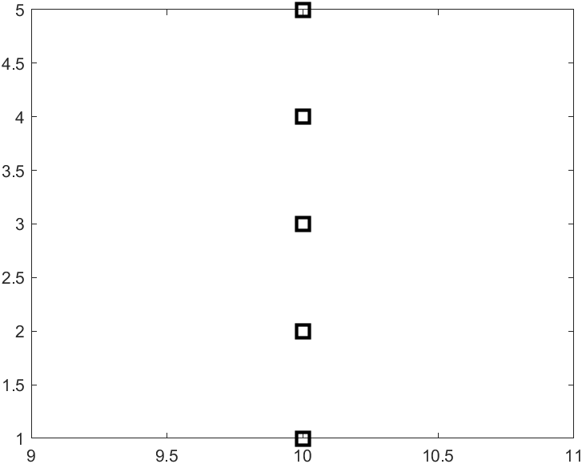
>> f = inline('x^3+6*x-2','x');
>> f(3)

ans =

43

>> f = inline('x.^3+6*x-2','x');
>> f([3 4 5])

ans =

43 86 153

>> x = linspace(0,5,6)

x =

0 1 2 3 4 5

>> plot(x,sin(x),'k--',x,cos(x),'ko')
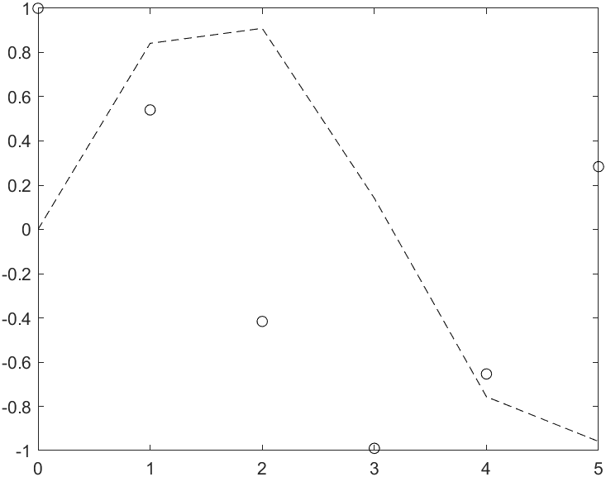
>> t=linspace(0,2*pi,100); x=2*cos(t); y=2*sin(t);
>> plot(x,y)
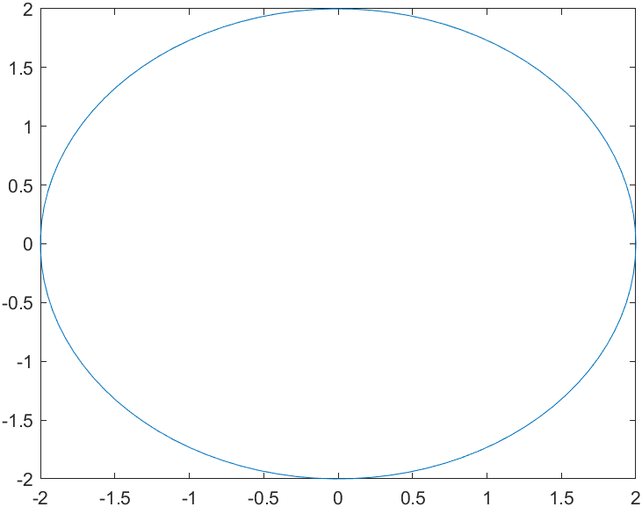
>> t=linspace(0,2*pi,100); x=2*cos(t); y=2*sin(t);
>> plot(x,y); axis square;
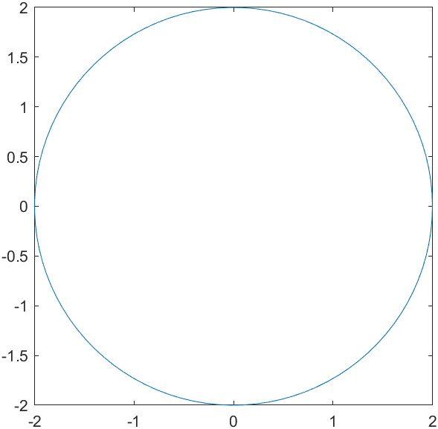
>> t=linspace(0,2*pi,100); x=2*cos(t); y=2*sin(t);
>> plot(x,y); axis equal
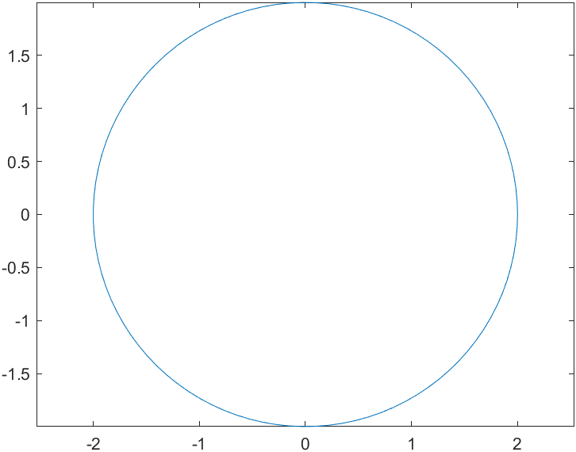
>> t=linspace(0,2*pi,100); x=2*cos(t); y=2*sin(t);
>> plot(x,y); axis image;
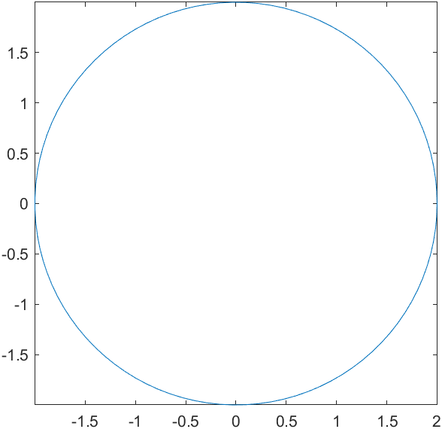
>> ones(3)

ans =

1 1 1
1 1 1
1 1 1

>> zeros(2)

ans =

0 0
0 0

>> C=[1 2 3]; length(C)

ans =

3

>> A=[1 2 3; 4 5 6; 7 8 9];
>> sum(A)

ans =

12 15 18

>> abs(-3)

ans =

3

>> fp = fopen('test.m','w'); %test.m란 파일을 쓰기용으로 생성
>> fprintf(fp, '%d %d\n', 1, 2); %파일에 1 2 쓰기
>> fprintf(fp, '%f %f\n', 3.5, 4.5); %파일에 3.5 4.5 쓰기
>> fprintf(fp, '%e %e\n', 100, 1000); %파일에 100 1000 쓰기
>> fclose(fp); %파일 close
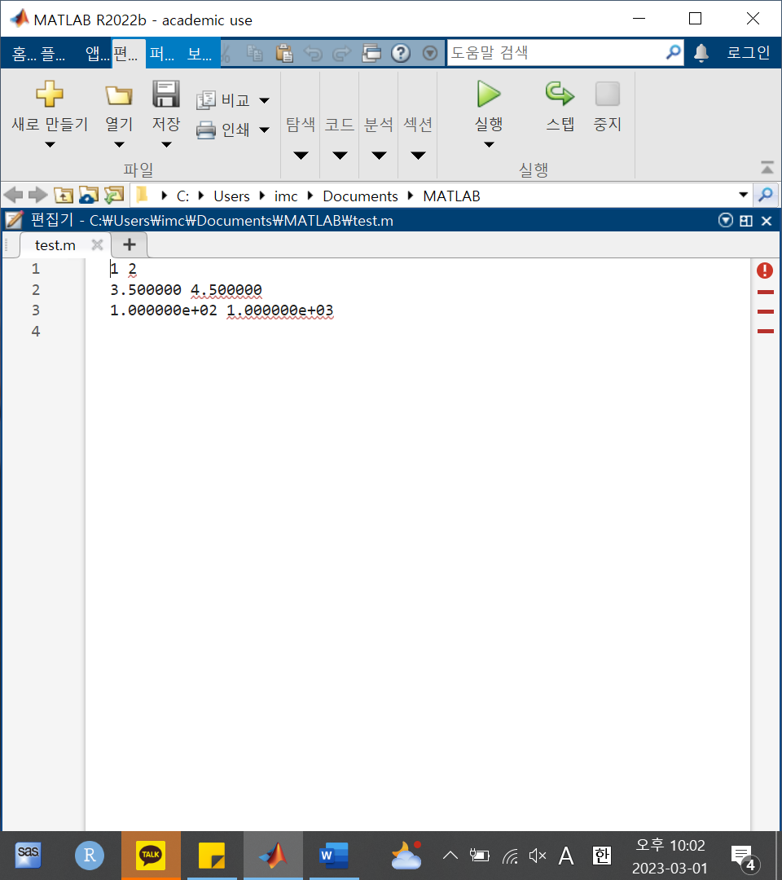
>> a = load('test.m');
>> a = 1.0e+003 *
a = 1.0e+003 *
↑
오류: 유효하지 않은 표현식입니다. 누락되거나 불필요한 문자가 있는지 확인하십시오.

>> Random_matrix = rand(2,3)

Random_matrix =

0.8147 0.1270 0.6324
0.9058 0.9134 0.0975

>> rand('seed',3)
>> rand(2,3)

ans =

0.5387 0.0512 0.3010
0.3815 0.2851 0.1277

