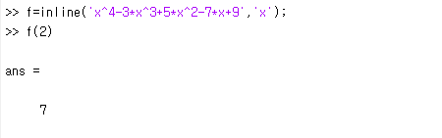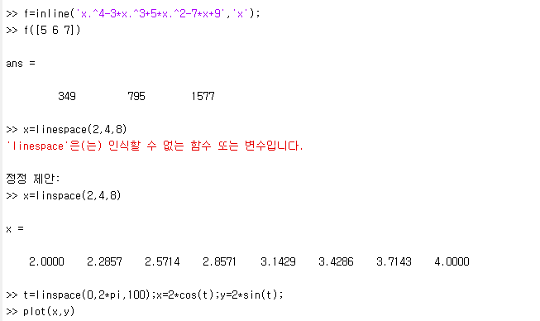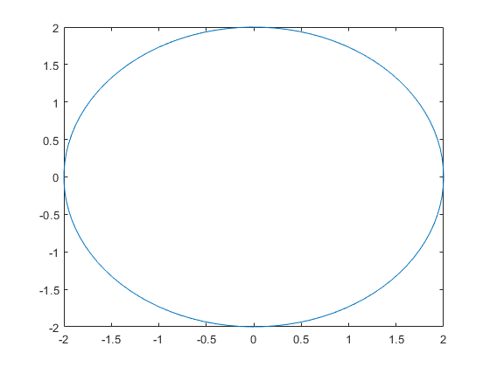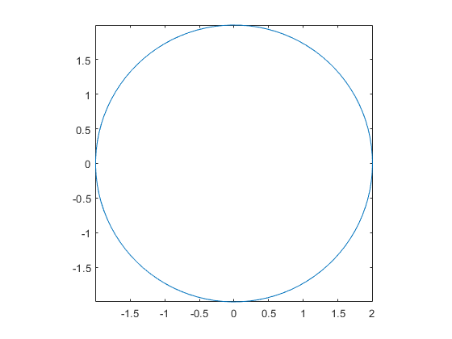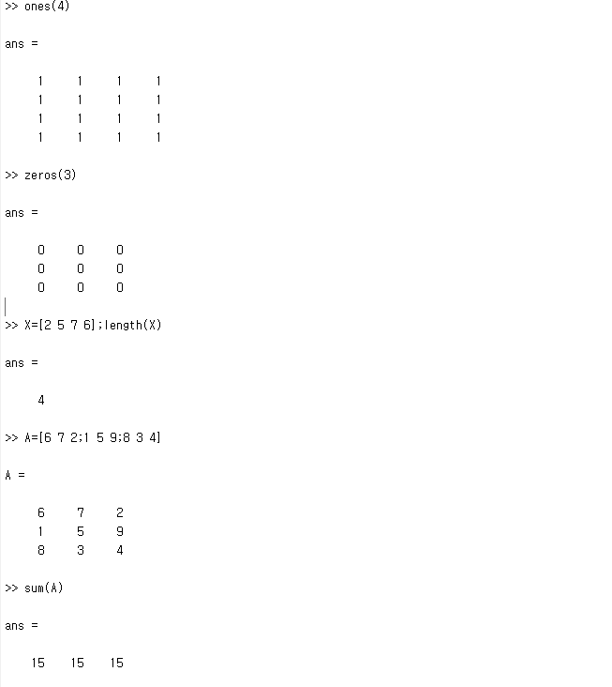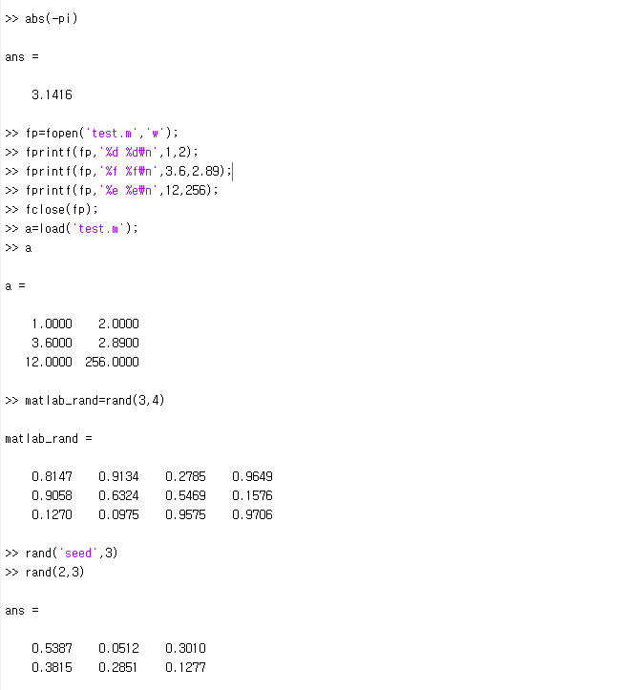

>> 4+7
ans =
11

>> 3-7
ans =
-4

>> 47*635
ans =
29845

>> 1331/11
ans =
121

>> 4756<6857
ans =
logical
1

>> 4756>6857
ans =
logical
0

>> 4756==3855+901
ans =
logical
1

>> 4756>=3855+901
ans =
logical
1

>> 4756<=3855+901
ans =
logical
1

>> x=[12 24 36 48 60]
x =
12 24 36 48 60

>> y=[5 4 3 2 1]
y =
5 4 3 2 1

>> x/12<y
ans =
1×5 logical 배열
1 1 0 0 0

>> x/12<=y
ans =
1×5 logical 배열
1 1 1 0 0

>> x/12==y
ans =
1×5 logical 배열
0 0 1 0 0

>> x/12>=y
ans =
1×5 logical 배열
0 0 1 1 1

>> x/12>y
ans =
1×5 logical 배열
0 0 0 1 1

>> x/12<=y | x/12>=y
ans =
1×5 logical 배열
1 1 1 1 1

>> x/12<=y & x/12>=y
ans =
1×5 logical 배열
0 0 1 0 0

>> for p=1:10
a=p
end

a =
1
a =
2
a =
3
a =
4
a =
5
a =
6
a =
7
a =
8
a =
9
a =
10

>> m=1;
>> n=-1;
>> if m<0
n=m+2
else
m=n-2
end

m =
-3

>> b=1;
>> while b<10
b=b^2+2
end

b =
3
b =
11

>> k=1;l=2;q=3
q =
3

>> clear

>> f=inline('x^4-3*x^3+5*x^2-7*x+9','x');
>> f(2)
ans =
7

>> f=inline('x.^4-3*x.^3+5*x.^2-7*x+9','x');
>> f([5 6 7])
ans =
349 795 1577

>> x=linspace(2,4,8)
x =

2.0000 2.2857 2.5714 2.8571 3.1429 3.4286 3.7143 4.0000

>> t=linspace(0,2*pi,100);x=2*cos(t);y=2*sin(t);
>> plot(x,y)

>> t=linspace(0,2*pi,100);x=2*cos(t);y=2*sin(t);
>> plot(x,y);axis image;

>> ones(4)
ans =
1 1 1 1
1 1 1 1
1 1 1 1
1 1 1 1

>> zeros(3)
ans =
0 0 0
0 0 0
0 0 0

>> X=[2 5 7 6];length(X)
ans =
4

>> A=[6 7 2;1 5 9;8 3 4]
>> sum(A)
ans =
15 15 15

>> abs(-pi)
ans =
3.1416

>> fp=fopen('test.m','w');
>> fprintf(fp,'%d %d\n',1,2);
>> fprintf(fp,'%f %f\n',3.6,2.89);
>> fprintf(fp,'%e %e\n',12,256);
>> fclose(fp);
>> a=load('test.m');
>> a
a =
1.0000 2.0000
3.6000 2.8900
12.0000 256.0000

>> matlab_rand=rand(3,4)
matlab_rand =
0.8147 0.9134 0.2785 0.9649
0.9058 0.6324 0.5469 0.1576
0.1270 0.0975 0.9575 0.9706

>> rand('seed',3)
>> rand(2,3)
ans =
0.5387 0.0512 0.3010
0.3815 0.2851 0.1277

